

SCHOOL OF ARCHITECTURE, COMPUTING AND ENGINEERING
Department of Engineering and Computing

Project Title
Student’s first and last name
Student Number

A report submitted in part fulfilment of the degree of
BSc (Hons) in Your Programme
Supervisor: Supervisor Name

CN6000

Write your abstract here. Remember, an abstract is 500 words of less. It is NOT an introduction to your project. It has to have three elements: Purpose of this project, how you did the project, and what is the outcome of this project. You do not cite sources in your abstract. It is likely to be the last thing you write.

Acknowledgments
Here you can thank the people, including your supervisor, who have helped you with your project.

Contents

Abstract 2
Acknowledgments 3
Chapter 1: Introduction 5
1.1 Sub-heading 5
Chapter 2: Literature Review 6
2.1 Second Level Headings 6
Chapter 3: Additional Sections 7
Chapter 4: Code 8
4.1 Source Code 8
Chapter 5: Evaluation 9
Chapter 6: Conclusion 10
References 11
Appendix A - Initial Project Proposal 12
Appendix B - Final Project Proposal 13
Appendix C - Application for the Approval of Research Activities to be Attached (if needed) 14
Appendix D – Client Consent Form to be Attached (if needed) 15
Additional Appendices (as needed) 16

Introduction
Write you introduction here.

Sub-heading
This is an example of a subheading. [delete as appropriate] Typical headings include 1.1. Introduction, 1.2. Purpose of this project, 1.3. Problem Statement, 1.4. Aim of the project, 1.5. Objectives of the project, 1.6. Structure of the project.

Literature Review
Write you literature review here. Remember, every paragraph and text that you research has to have a citation and referencing using the Harvard approach. Check lesson 4 for the correct citation and references using the Harvard approach. Students who do not use the Harvard approach risk failing the project.
Example of correct Harvard citation and references below:
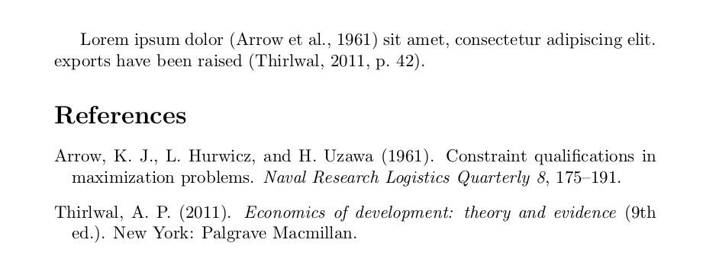

Second Level Headings

Third Level Headings

Be critical of the literature you read. Consider having a section called – ‘Gaps in the literature’ where you talk about things you could not find or not explained well in the literature.

Project Methodology
Explain the process you used to do the project. Please refer to lesson 6 for more details. Make sure you have a section that looks at Legal, Ethical, and Environmental Considerations.

Results/Findings/Outcomes
Depending on your topic, you may have variety of things to report here. But these are objective reporting without stating your opinion on the results you are getting. This will happen in the next chapter.

Source Code
Use the Code style for presenting code snippets within this report. Please include snippets, rather than 1,000s of line of code which should be placed in an appendix or, if very large, in a separate document. If you have no code, then other implementation artifacts (e.g. screenshots) can be placed here if not evidenced elsewhere.
static public void main(String[] args) {
try {
UIManager.setLookAndFeel(UIManager.getSystemLookAndFeelClassName());
}
catch(Exception e) {
e.printStackTrace();
}
new WelcomeApp();
}

Evaluation
Include an evaluation of both product and process. You need to be objective in evaluating your work. Make sure you have a reflection here on what worked and what did not work.

Conclusion
Write the conclusion of your project as well as any information related to future work. Remember to reflect on the key findings, limitations of these findings, and future opportunities to extend this work. Maybe a student next year can take your project and extend it!

Reference List
Ensure that your list of references using the Harvard format and is consistent with the citations in you report. Refer to lessons 4 and 7 for more details.

The references should look something like this:


Appendix A - Initial Project Proposal
Project (CN6000) Initial Proposal Form

Programme: Year:

Student Number:

Proposed Title:

Proposed Aim:
(Please provide a brief summary of what you hope to achieve by the end of your project. Your proposed aim should clearly identify your topic of interest.)

Rationale:
(Please provide a detailed explanation of why you think this project needs to be undertaken.)

Supervisor:

Appendix B - Final Project Proposal
Project (CN6000) Final Proposal Form

Programme: Year:

Student Number:

Proposed Title:

Proposed Aim:
(Please provide a brief summary of what you hope to achieve by the end of your project. Your proposed aim should clearly identify your topic of interest.)

Objectives: (Please provide a list of the objectives you need to achieve for your project to succeed.)

Rationale:
(Please provide a detailed explanation of why you think this project needs to be undertaken.)

Facilities required: (Please provide a detailed list of what you will need to do implement your solution)

Supervisor:

Appendix C - Application for the Approval of Research Activities to be Attached (if needed)

Appendix D – Client Consent Form to be Attached (if needed)

Additional Appendices (as needed)

